**MCA 2nd Semester**

Name:-Lakshita Joshi

Roll no. :-16

Subject:-Cloud Computing

Topic:-GCP Immersive Stream for XR

**GCP Immersive Stream for XR**

This document outlines Google Cloud Platform's (GCP) Immersive Stream for XR, a technology designed to deliver high-fidelity, interactive XR experiences to users on a wide range of devices without requiring powerful local hardware. It explores the core concepts, architecture, benefits, use cases, and considerations for leveraging Immersive Stream for XR to create compelling and accessible XR applications.

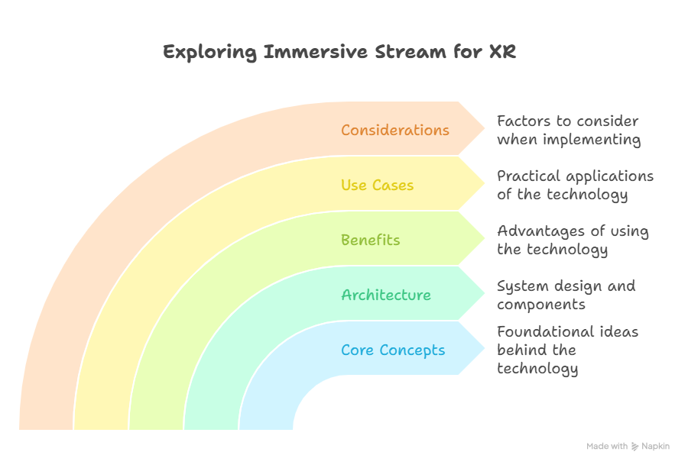

**Core Concepts**

Immersive Stream for XR leverages cloud rendering and streaming technologies to offload the computationally intensive tasks of XR rendering to powerful servers in the cloud. This allows users to access XR experiences on devices with limited processing power, such as mobile phones, tablets, and standalone XR headsets. The key concepts include:

* **Cloud Rendering:** XR content is rendered on high-performance GPUs in the cloud. This eliminates the need for users to have powerful local hardware.
* **Real-time Streaming:** The rendered frames are streamed to the user's device in real-time, providing a responsive and interactive XR experience.
* **Interactive Input:** User input, such as head tracking, hand tracking, and controller input, is captured on the user's device and transmitted to the cloud server.
* **Low Latency:** Immersive Stream for XR is designed to minimize latency, ensuring a smooth and immersive experience.
* **Scalability:** The cloud infrastructure can scale to support a large number of concurrent users.

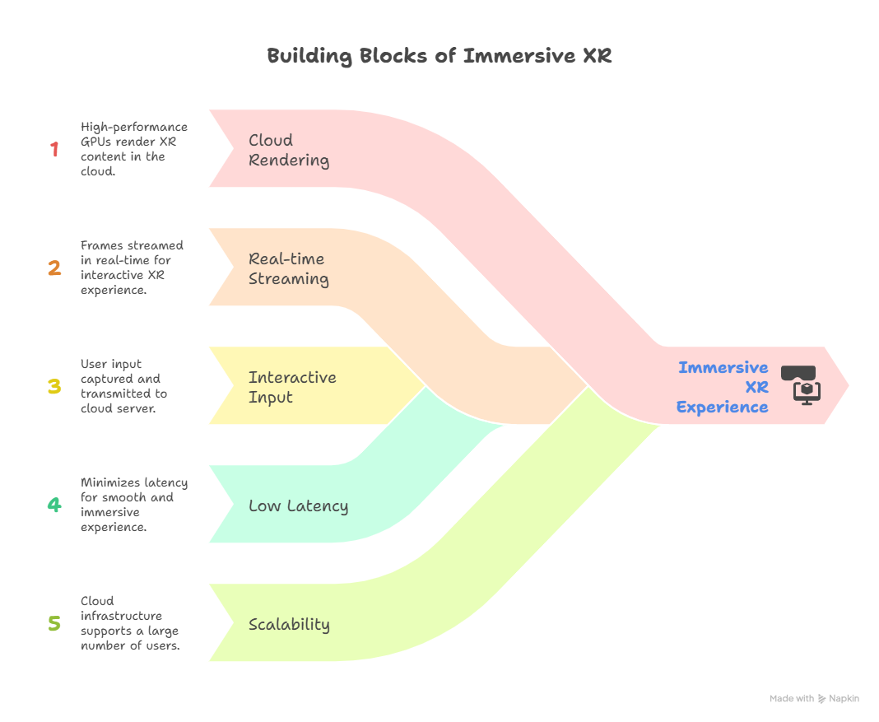

**Architecture**

The typical architecture of an Immersive Stream for XR application involves the following components:

1. **XR Application:** This is the application that defines the XR experience, including the 3D models, interactions, and logic. It is typically developed using a game engine like Unity or Unreal Engine.
2. **Cloud Rendering Server:** This server hosts the XR application and renders the frames. It is equipped with high-performance GPUs and CPUs.
3. **Streaming Server:** This server streams the rendered frames to the user's device. It uses optimized streaming protocols to minimize latency and bandwidth usage.
4. **Client Application:** This application runs on the user's device and receives the streamed frames. It also captures user input and transmits it to the cloud server.
5. **GCP Infrastructure:** The entire system is hosted on GCP, leveraging services such as Compute Engine, Cloud Storage, and Cloud CDN.

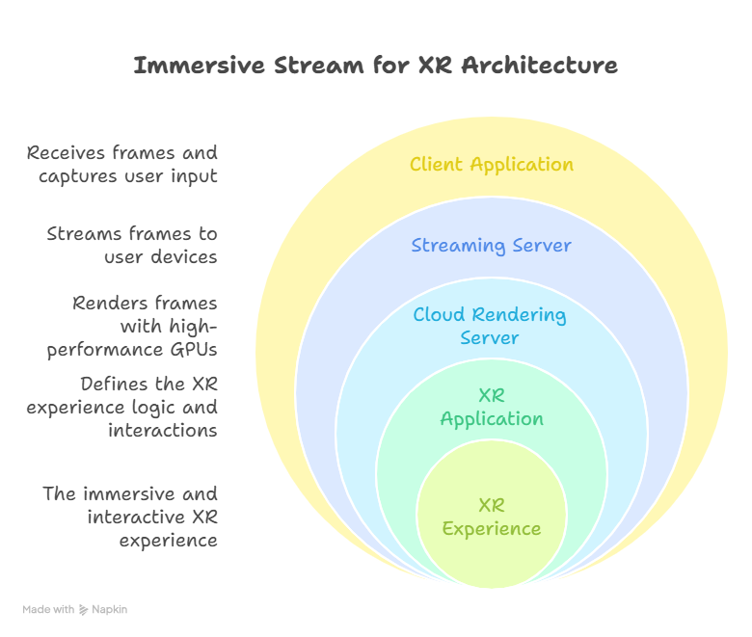

**Benefits**

Using Immersive Stream for XR offers several benefits:

* **Accessibility:** Enables XR experiences on a wider range of devices, including low-powered mobile devices.
* **Scalability:** Easily scales to support a large number of concurrent users.
* **High Fidelity:** Delivers high-quality graphics and immersive experiences.
* **Reduced Hardware Costs:** Eliminates the need for users to purchase expensive XR-ready hardware.
* **Simplified Deployment:** Simplifies the deployment and management of XR applications.
* **Cross-Platform Compatibility:** Supports a variety of client devices and operating systems.
* **Content Protection:** Protects XR content from piracy and unauthorized access.

